|  |
| --- |
| **Specialization in Machine Learning** |

** Department of CSE (AI & ML) & CSE (Data Science)**

**G. Narayanamma Institute of Technology & Science**

**(Autonomous) (for women)**

**(Autonomous) (For Women)**

**Approved by AICTE, New Delhi & Affiliated to JNTUH, Hyderabad**

**Accredited by NBA & NAAC, an ISO 9001:2015 Certified Institution**

**Shaikpet, Hyderabad-500104**

**GNR- 22 , (2024 - 2025) III B.Tech II Sem Mini Project**

On “MediVision**”**

Under the guidance of

**Mr. Mahendra M** , Asst.Prof.

**Abstract**

MediVision focuses on developing a machine learning (ML) system to recommend drugs and predict overdose risks based on the patient’s present symptoms. The primary goal of the system is to assist healthcare professionals and patients by providing accurate, symptom-based drug suggestions while simultaneously identifying potential overdose risks to prioritize safety and well-being. The system works by analyzing reported symptoms by applying Support Vector Classifier, Random Forest Classifier , Gradient Boosting Classifier , K Neighbors Classifier, Multinomial Naive Bayes Algorithms to suggest the most appropriate medications. By leveraging data-driven approaches, this platform empowers users to make more informed decisions. For healthcare professionals, it acts as a reliable decision-support tool, enabling faster and more accurate prescribing. For patients, it offers an added layer of confidence and safety when managing symptoms. ML system has the potential to significantly improve healthcare outcomes and enhance overall patient care.

**Hardware Requirements:** Hard Disk: 500 GB, RAM: 4 GB, Processor: i3

**Software Requirements:** Python, HTML ,CSS , Flask, Machine Learning ,Scikit-learn.

*Dept R&D: No * If No : GN ITS

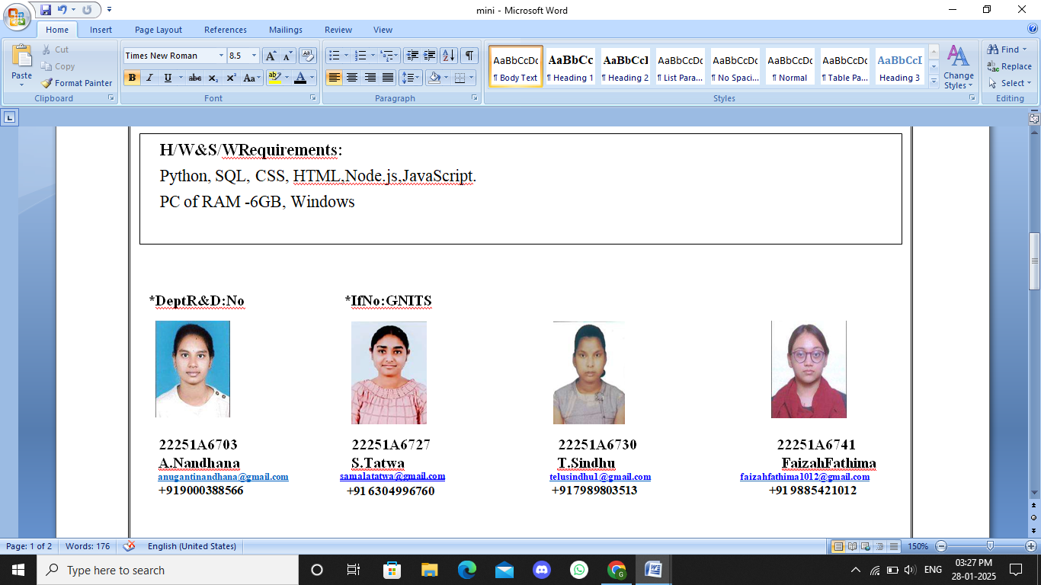 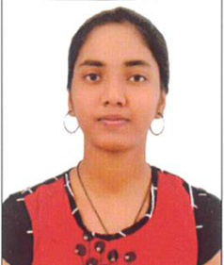  

22251A6703 22251A6716 22251A6727 22251A6741 **A.Nandhana** G.Shivatejaswini **S.Tatwa Faizah Fathima**

**[anugantinandhana@gmail.com](mailto:anugantinandhana@gmail.com)** [gaishivatejaswini29@gmail.com](mailto:gaishivatejaswini29@gmail.com) [samalatatwa@gmail.com](mailto:samalatatwa@gmail.com) [faizahfathina1012@gmail.com](mailto:faizahfathina1012@gmail.com)

**+919000388566 +917013862671 +91 6304996760 +91 9885421012**

**Internal Guide Class Coordinator Mini Project Coordinator Head of Department**

**Mr. Mahendra M Mrs. K.Sreeveda Msr.N.Divya Dr. O. Obulesu**

**Mrs. T.Mallika Devi**